MONGO DB

[{

        "name": "Sita",

        "age": 25,

        "Hobbies": [

          "Walk",

          "Cricket"

        ],

        "identity": {

          "hasPanCard": false,

          "hasAdhaarCard": true

        },

        "bio": "I am a youtuber",

        "experience": [

          {

            "company": "Spotify",

            "duration": 3

          },

          {

            "company": "Paytm",

            "duration": 1

          }

        ]

      },

      {

        "name": "Shyam",

        "age": 11,

        "Hobbies": [

          "Walking",

          "Reading"

        ],

        "identity": {

          "hasPanCard": false,

          "hasAdhaarCard": true

        },

        "bio": "I am a youtuber and actor"

      },

      {

        "name": "Ghanshayam",

        "age": 11,

        "Hobbies": [

          "Walk",

          "Cricket"

        ],

        "identity": {

          "hasPanCard": false,

          "hasAdhaarCard": true

        },

        "bio": "I am a cook",

        "experience": [

          {

            "company": "Times Internet",

            "duration": 1

          },

          {

            "company": "1 mg",

            "duration": 1

          },

          {

            "company": "Apple",

            "duration": 2

          }

        ]

      },

      {

        "name": "Rita",

        "age": 11,

        "Hobbies": [

          "Anime"

        ],

        "identity": {

          "hasPanCard": false,

          "hasAdhaarCard": true

        },

        "bio": "I play games"

      },

      {

        "name": "Ram",

        "age": 10,

        "Hobbies": [

          "Walk",

          "Cricket"

        ],

        "identity": {

          "hasPanCard": false,

          "hasAdhaarCard": true

        },

        "bio": "I do nothing.",

        "experience": [

          {

            "company": "KPMG",

            "duration": 1

          },

          {

            "company": "EY",

            "duration": 1.5

          },

          {

            "company": "TCS",

            "duration": 0.5

          }

        ]

      },

      {

        "name": "Geeta",

        "age": 12,

        "Hobbies": [

          "Gaming",

          "Cooking"

        ],

        "identity": {

          "hasPanCard": false,

          "hasAdhaarCard": true

        },

        "bio": "I code and play games.",

        "experience": [

          {

            "company": "Spotify",

            "duration": 1

          },

          {

            "company": "Google",

            "duration": 3.4

          }

        ]

      },

      {

        "name": "Geeta",

        "bio": "I just code.",

        "experience": [

          {

            "company": "Amazon",

            "duration": 2

          },

          {

            "company": "Flipkart",

            "duration": 1

          }

        ],

        "Hobbies": [

          "Reading",

          "Walking"

        ]

      },

      {

        "name": "Akshit",

        "age": 22,

        "hobbies": [

          "TV Shows"

        ],

        "hasMacBook": true,

        "bio": "I am savage boi.",

        "experience": [

          {

            "company": "Amazon",

            "duration": 2

          },

          {

            "company": "Google",

            "duration": 3

          }

        ]

      }]

 const data = await model1.find({'identity.hasAdhaarCard':true})

        res.status(200).json({data:data})

    } catch (error) {

        res.status(400).json({error:error})

    }

 const data = await model1.find({age:{$nin:[25,22]}})

// const data = await model1.find({age:{$in:[25,22]}})

// const data = await model1.find({age:{$gt:[25,22]}})

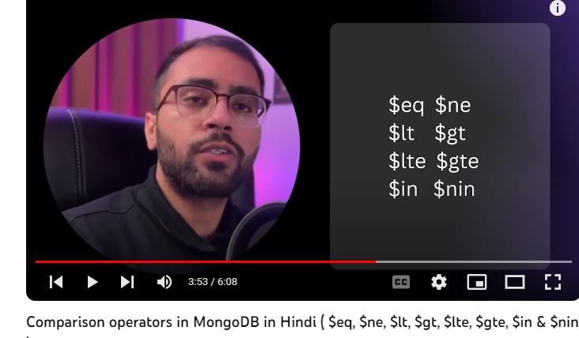

* $eq : equal to
* $ne :not equal
* $lt : less then:
* $gt : greatet then
* $lte:less then equal to
* $gte : greater then equal to
* $in : check it present in list like we find age [22,25]
* $nin : not in list

**Logical Operators in MongoDB in Hindi ( $not, $and, $or & $nor)**

const logicalOperator = async(req,res)=>{

  try {

    //find age less then 10 and greater then 12

    // const data =await model1.find({$or :[{age:{$lte:10}} ,{age:{$gte:12}}]})

    //nor operator

    // const data =await model1.find({$nor :[{age:{$lte:10}} ,{age:{$gte:12}}]})

    //using end operator   age less then 11 and hobbies = 'Walk'

    // const data =await model1.find({$and :[{age:{$lt:11}} ,{Hobbies:'Walk'}]})

    //direct 2 queries on age but it wrong  use $and in this json pick last quert age:{$gte:20}

    const data =await model1.find({age:{$lt:11} ,age:{$gte:20}})

      res.status(200).json({data:data})

  } catch (error) {

      res.status(400).json({error:error})

  }

}

# Mastering MongoDB: Understanding the $exists and $type Operators

// Mastering MongoDB: Understanding the $exists and $type Operators

const existOperators = async(req,res)=>{

  try {

    //check field hasMacBook present in any document

    // const data =await model1.find({hasMacBook:{$exists:true}})

    // const data =await model1.find({hasMacBook:{$exists:true,$eq:true}})

    //wo doc gen ma hasMacBook ki type Boolean ho

    const data =await model1.find({hasMacBook:{$exists:true,$type:"bool"}})

      res.status(200).json({data:data})

  } catch (error) {

      res.status(400).json({error:error})

  }

}

# Evaluation Operators

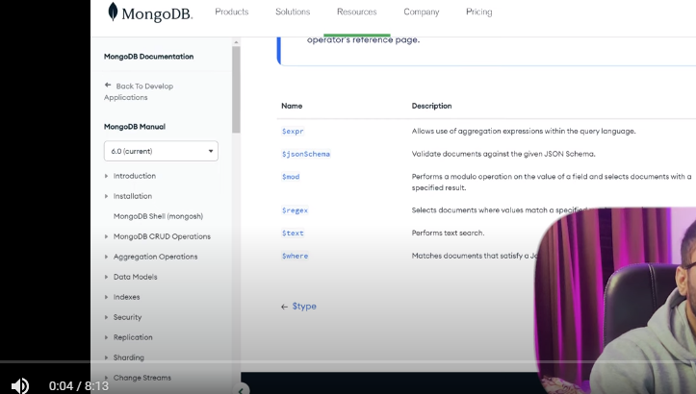

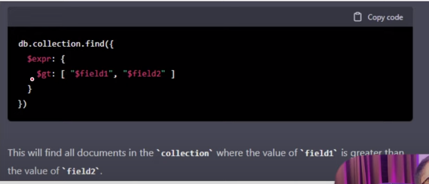

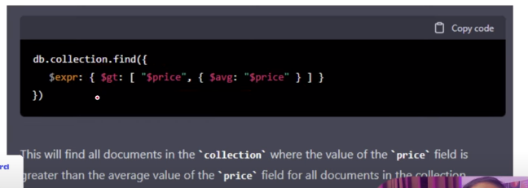

$regr : regular expression